7th Bulletin on Covid-19 Relief Services (April & May’2021)
Mahesh, a 32 year old, affected by the corona virus was rushed to the hospital premises as he struggled to breathe. Upon arrival, he was met with an impossibly long queue, full of many other Maheshs waiting to be treated. The hospital put up ‘beds full’ signs and closed its gates. Mahesh and his family, with nowhere else to go, continued to wait outside desperately as Mahesh battled the deadly effects of the virus.
Mahesh is one among the thousands of people in the country whose lives were prematurely seized away. And while we’re losing many lives to the virus, we’re also losing lives due to the economic impact of the pandemic. Unemployment rates are at an all-time high and without steady jobs, many are unable to afford basic amenities like food and shelter.
To help those in need during a crisis like this, we, at Ashray Akruti, have set up COVID Relief Services. Just like with any health-related crisis, the underprivileged are always the worst affected. Through our relief efforts, we have been actively reaching out to vulnerable communities to help curb the spread of the virus. We believe precaution and prevention is the only way to reduce the burden on our fragile healthcare system.

Multiple approaches to revitalize:

Type’s recipients served in the table:

To tackle with the growing number of cases, many states in India declared lockdowns limiting movement. The much-needed move however, brought new challenges with it. Apart from already being unable to afford basic necessities, people were now forced to remain indoors with no means of fending for themselves.
Extending our help even during lockdowns, our team of dedicated volunteers, Samaritans, and frontline workers continue to provide relief services.
Not discounting mental trauma, we also announced and activated a range of initiatives designed to help patients and their families cope with medical emergencies, financial upheaval, and bereavement support. We understand and empathise with families who have lost loved ones and are working tirelessly to help them process the loss and find their way back into the society.

Case Study
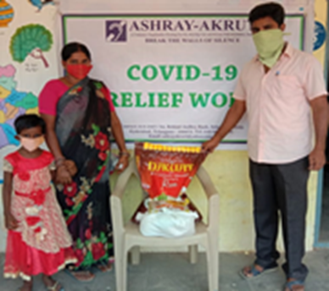

Hailing from Quthbullapur, a suburb in Hyderabad, Ameen Bee supports a family of five, including her daughter, son-in-law, and two granddaughters. Her son-in-law Fareed has been off work for a while due to an injury that left him paralyzed. Leaving the responsibility of looking after the family, solely on Ameen. Amidst their daily struggles to make ends meet, the lockdown added to Ameen’s woes as she was now unable to venture out for work.

Ashray Akruti works with families like Ameen Bee to ensure they have access to basic requirements.

“Thanks to Ashray Akruti and Give India, I now have adequate supplies required for my family. Their help came right on time. I’m glad my family can finally have full meals in a day.” – Ameen Bee

Picture Gallery
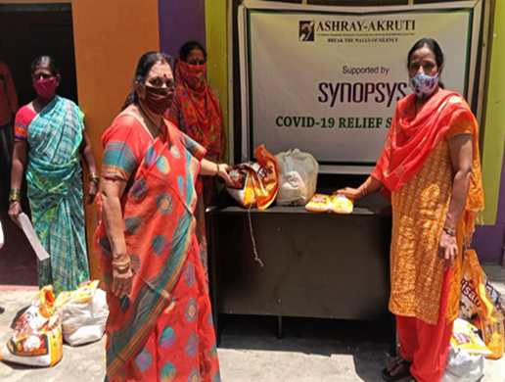 | 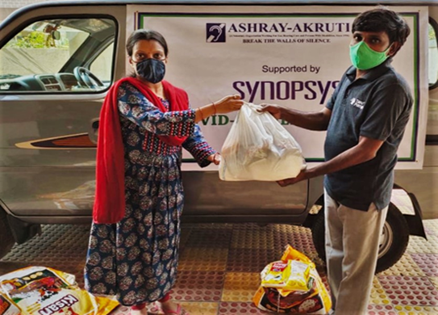
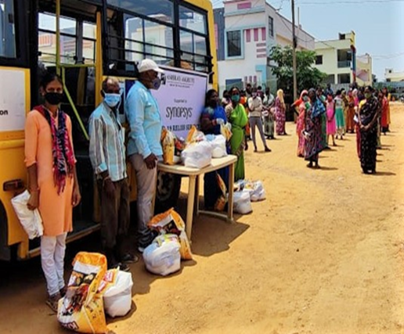 | 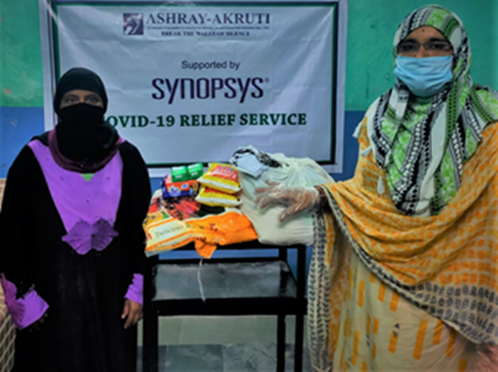
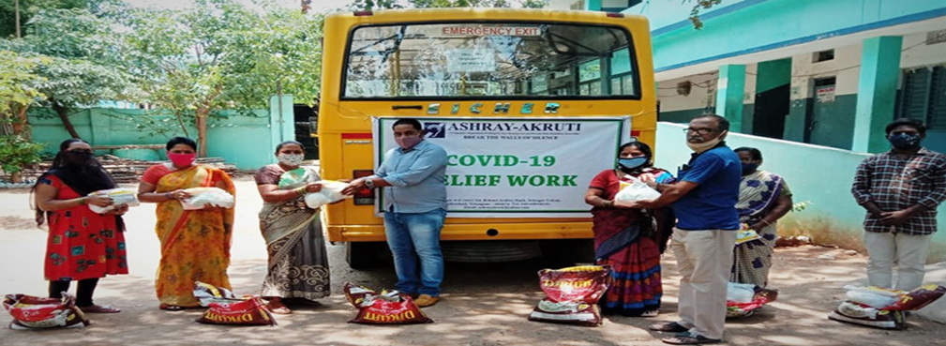 | 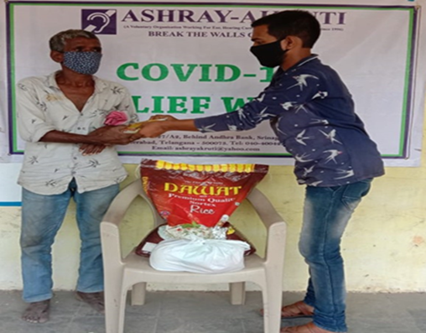

Donors impacted the lives of PwDs & the defenseless communities

Donors impacted the lives of PwDs and other defenseless communities during the months of April’2021 & May’ 2021
S. NO | Name of the Donor
1 | Give India foundation
2 | Synopsys India Pvt. Ltd.
3 | Individual donors

We are proud to be a part of a team that has risen to the occasion to support communities in need. We help collect and distribute groceries, hygiene products, sanitizers, and medical kits. We prioritize providing relief to the elderly and disabled people, disadvantaged families, children, pregnant women, adolescent girls, destitute, including migrant workers and slum dwellers.
Our efforts also include creating awareness of the situation and educating communities on how to prevent further spreading.
We are grateful to all our generous donors, Foundations, Corporates, Trusts, and volunteers for extending their support to us. It has helped us reach out to more people to make a significant impact.
Appeal:

In order to continue reaching out to those in need during these difficult times, we need your help. Your generous contributions will allow us to widen our reach and offer timely help to those usually left behind. Together, we can make a difference.
Please reach out to us for more information on our relief services. We’re always open to new ideas and suggestions too.
- Ms. Ashwini - +91- 8885536651 ashwini.s@ashrayakruti.in
- Ms. Jayanthi- +91-7032700810 jayanthi.b@ashrayakruti.in

